Batch: C3 Roll No.: 16010123217

Experiment No. 10

Grade: AA / AB / BB / BC / CC / CD /DD

Signature of the Staff In-charge with date

TITLE: Implementation of Memory Allocation Algorithms-BF,WF,FF
_____________________________________________________________________

AIM: Implementation of Basic CPU Scheduling Algorithms – Non Preemptive [FCFS , SJF]
______________________________________________________________________
Expected Outcome of Experiment:

CO5 Understand Storage management with allocation _____________________________________________________________________
Books/ Journals/ Websites referred:
- Silberschatz A., Galvin P., Gagne G. “Operating Systems Principles”, Willey Eight edition.
- Achyut S. Godbole , Atul Kahate “Operating Systems” McGraw Hill Third
Edition.
- William Stallings, “Operating System Internal & Design Principles”, Pearson.
- Andrew S. Tanenbaum, “Modern Operating System”, Prentice Hall.
_____________________________________________________________________
Pre Lab/ Prior Concepts:
Memory is central to the operation of computing systems.
Memory = a large array of words/bytes.
Each byte or word has its own address.
Memory contains the program to be executed and data, both.
Program is executed line by line with Instruction Fetch, Instruction Decode, Operand Fetch, Execute cycles.
Program counter contains the address of the memory location to be executed next.
Memory consists of a large array of words or bytes, each with its own address.
The CPU fetches instructions from memory according to the value of the program counter. These instructions may cause additional loading from and storing to specific memory addresses.
A typical instruction-execution cycle, for example,
first fetches an instruction from memory.
The instruction is then decoded and may cause operands to be fetched from memory.
After the instruction has been executed on the operands, results may be stored back in memory.
Memory unit only sees a stream of addresses + read requests, or address + data and write requests

Description of the application to be implemented:
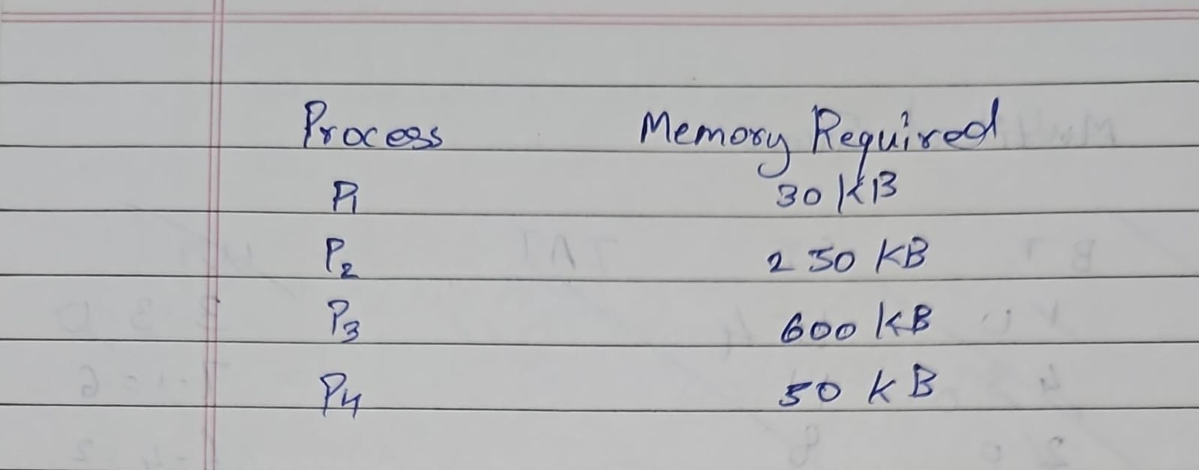
First Fit:
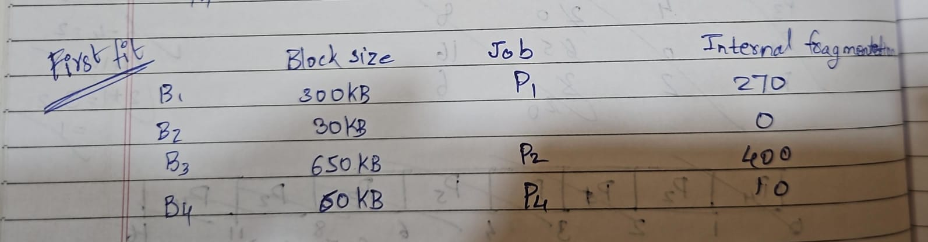

Best Fit :
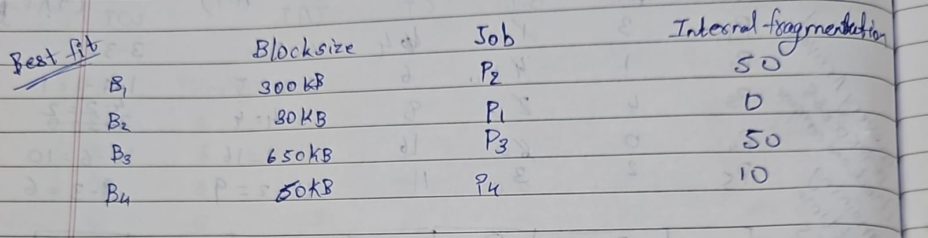

Worst Fit :
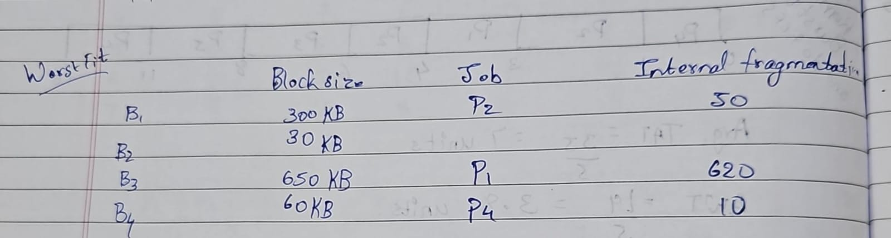
Implementation details:
Code:
#include <bits/stdc++.h>
using namespace std;

void firstFit(vector<int> partition, vector<int> process) {
int n = process.size();
int m = partition.size();
vector<int> alloc(n, -1);

for (int i = 0; i < n; i++) {
for (int j = 0; j < m; j++) {
if (partition[j] >= process[i]) {
alloc[i] = j;
partition[j] = -1;
break;
}
}
}

cout << "First Fit Allocation:\nProcess No.\tProcess Size\tPartition No.\n";
for (int i = 0; i < n; i++) {
cout << i + 1 << "\t\t" << process[i] << "\t\t";
if (alloc[i] != -1) cout << alloc[i] + 1;
else cout << "Not Allocated";
cout << endl;
}
}

void bestFit(vector<int> partition, vector<int> process) {
int n = process.size();
int m = partition.size();
vector<int> alloc(n, -1);

for (int i = 0; i < n; i++) {
int bestIdx = -1;
for (int j = 0; j < m; j++) {
if (partition[j] >= process[i]) {
if (bestIdx == -1 || partition[j] < partition[bestIdx]) {
bestIdx = j;
}
}
}
if (bestIdx != -1) {
alloc[i] = bestIdx;
partition[bestIdx] = -1;
}
}

cout << "\nBest Fit Allocation:\nProcess No.\tProcess Size\tPartition No.\n";
for (int i = 0; i < n; i++) {
cout << i + 1 << "\t\t" << process[i] << "\t\t";
if (alloc[i] != -1) cout << alloc[i] + 1;
else cout << "Not Allocated";
cout << endl;
}
}

void worstFit(vector<int> partition, vector<int> process) {
int n = process.size();
int m = partition.size();
vector<int> alloc(n, -1);

for (int i = 0; i < n; i++) {
int worstIdx = -1;
for (int j = 0; j < m; j++) {
if (partition[j] >= process[i]) {
if (worstIdx == -1 || partition[j] > partition[worstIdx]) {
worstIdx = j;
}
}
}
if (worstIdx != -1) {
alloc[i] = worstIdx;
partition[worstIdx] = -1;
}
}

cout << "\nWorst Fit Allocation:\nProcess No.\tProcess Size\tPartition No.\n";
for (int i = 0; i < n; i++) {
cout << i + 1 << "\t\t" << process[i] << "\t\t";
if (alloc[i] != -1) cout << alloc[i] + 1;
else cout << "Not Allocated";
cout << endl;
}
}

int main() {
cout << "Enter the number of partitions:" << endl;
int n; cin >> n;
cout << "Enter the number of processes:" << endl;
int m; cin >> m;

cout << "Enter the size of each partition:" << endl;
vector<int> partition(n);
for (int i = 0; i < n; i++) cin >> partition[i];

cout << "Enter the size of each process:" << endl;
vector<int> process(m);
for (int i = 0; i < m; i++) cin >> process[i];

firstFit(partition, process);
bestFit(partition, process);
worstFit(partition, process);

return 0;
}

Output: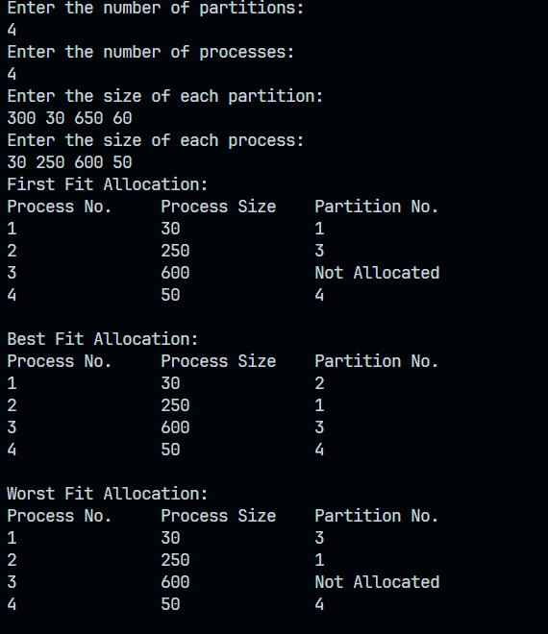

Conclusion :

From this experiment we learnt about various fitting techniques like first fit, best fit and worst fit and their advantages and disadvantages.

Post Lab Descriptive Questions

- Consider six memory partitions of size 200 KB, 400 KB, 600 KB, 500 KB, 300 KB and 250 KB. These partitions need to be allocated to four processes of sizes 357 KB, 210 KB, 468 KB and 491 KB in that order.
Perform the allocation of processes using- First Fit Algorithm, Best Fit Algorithm, Worst Fit Algorithm

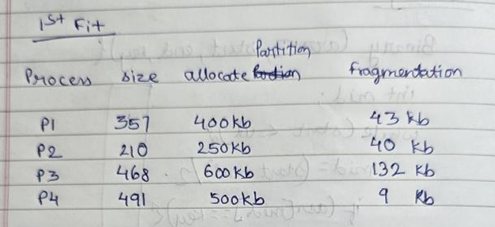
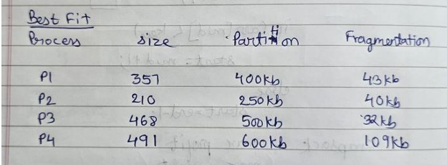

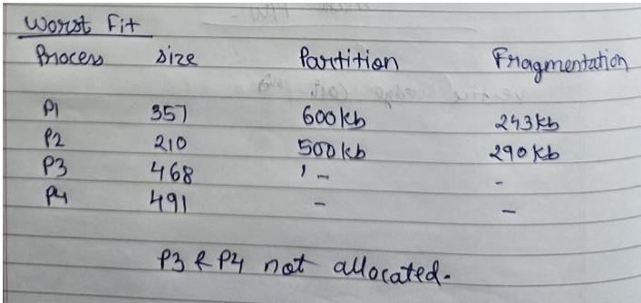
- Explain Buffering and its types in detail.

Core Concept of Buffering
A buffer is essentially a memory area that acts as a temporary holding space for data. It serves as an intermediary between a producer (which generates data) and a consumer (which processes that data). Buffering helps to:
- Smooth out speed differences between producer and consumer
- Reduce waiting time for resources
- Optimize data transfer operations
- Prevent data loss when systems operate at different rates

Types of Buffering

1. Single Buffering
In single buffering, only one buffer is used to hold data between the producer and consumer.
- Process: Data is read into the buffer, then processed from the buffer
- Limitation: The producer must wait for the consumer to finish before loading new data
- Example: Early keyboard input systems where typing had to pause while the system processed each keystroke

2. Double Buffering
Double buffering uses two separate buffer areas to improve efficiency.
- Process: While the consumer reads from one buffer, the producer fills the other
- Advantage: Reduces idle time since the producer and consumer can work simultaneously
- Example: Video rendering where one frame is displayed while the next frame is being prepared

3. Circular Buffering (Ring Buffer)
A circular buffer is a fixed-size buffer that works as if the beginning and end are connected.
- Structure: Uses pointers to track read and write positions
- Operation: When reaching the end, wraps around to the beginning
- Applications: Audio streaming, keyboard input queues, network packet processing
- Advantage: Efficient memory usage with minimal overhead

4. Elastic Buffering
Elastic buffers can dynamically grow or shrink based on the amount of data being handled.
- Feature: Adapts to varying data rates
- Implementation: Often uses linked lists or dynamic arrays
- Applications: Stream processing, adaptive media playback
- Advantage: Better handling of unpredictable data rates

5. Cache Buffering
A specialized form of buffering that stores frequently accessed data for faster retrieval.
- Purpose: Reduce access time to frequently used data
- Mechanism: Keeps copies of data from slower storage in faster memory
- Example: CPU cache, disk cache, web browser cache

6. I/O Buffering
Specific to input/output operations, helping to optimize data transfer between devices and applications.
- Types:
  - Unbuffered I/O: Data transferred directly without buffering
  - Line-buffered: Buffer flushed when a newline character is encountered
  - Fully-buffered: Buffer flushed when it becomes full
- Applications: File operations, terminal I/O, network communications

Buffering Strategies

1. Producer-Consumer Problem Solutions
- Semaphores: Control access to the buffer
- Monitors: Higher-level synchronization constructs
- Message Passing: Direct communication between processes

2. Buffer Overflow Prevention
- Bound checking: Verify data fits before writing
- Dynamic resizing: Grow the buffer as needed
- Flow control: Slow down the producer when necessary

Applications of Buffering
- Multimedia: Video playback, audio streaming
- Networking: Packet handling, transmission control
- File Systems: Read-ahead buffering, write-back caching
- Graphics: Frame buffering for smooth animations
- Database Systems: Query result buffering
Buffering is a fundamental concept in computing that balances performance, reliability, and resource utilization across virtually all computing domains.

Date: 13-03-2025 Signature of faculty in-charge

